CONDITIONS AND TERMS OF USE
pan-learning.org and associated pages are licensed under a Creative Commons Attribution-NonCommercial-ShareAlike 4.0 International License. Permissions beyond the scope of this license may be available.
To access most of the material on the pan-learning.org site, you will need an account. Please register through the account creation page.
In case of issues, please consult the support page

PAN-LEARNING DATA COLLECTION POLICY
When you create an account at pan-learning you can rest assured that we will not pass on your personal information to third parties.
If you are enrolled in one or several courses at pan-learning, the designated teachers and students of those courses at pan-learning will have access to see your registration data.
If you have enrolled in one or or several courses at pan-learning, the designated teacher(s) of those courses will have access to track your progress within the course including attempts and grades in quizzes. Fellow students will not have access to track your progress including attempts and grades in quizzes.
By signing up to pan-learning you certify your acceptance of the above data collection policy.
As a pan-learning user, you may at any time contact us to request information on / removal of your user records.
For ease of communication, PLEASE register your email address at the mailinglist: https://lists.esss.dk/mailman/listinfo/pan-learning-users.

PAN-LEARNING.ORG TEAM
Project leader: Thomas Holm Rod, DRAM group leader, ESS DMSC, Copenhagen
E-learning lead: Linda Udby, Associate Professor, Niels Bohr Institute, University of Copenhagen
Technical platform development leader: Peter Willendrup, Senior Research Engineer, Technical University of Denmark
Course content and didactical developers: Viktor Holm, Research Assistant, Niels Bohr Institute, University of Copenhagen & Linda Udby, Associate Professor, Niels Bohr Institute, University of Copenhagen & Jesper Bruun, Assistant Professor, Department of Science Education, University of Copenhagen

LIST OF CONTENT CONTRIBUTORS
University of Copenhagen:
Kim Lefmann, Linda Udby, Pia Jensen Ray, Julie Hougaard, Lise Arleth, Kell Mortensen, Bente Lebech, Jesper Bruun
Institut Laue-Langevin, ILL:
Andrew Wildes, Alain Filhol, Helmut Schober
Technische Universität München:
Jörg Pulz, Peter Link, Jürgen Neuhaus
European Spallation Source, ESS:
Markus Strobl

TECHNOLOGY PLATFORM
The pan-learning.org platform is composed of three main parts:
- An online course system featuring exercises and quizzes provided by a Moodle installation
- A set of wiki pages provided by a MediaWiki installation
- An online simulator platform based on McStas and Django
Online documentation for the setup of the platform is available at our documentation wiki on GitHub

FUNDING
The current funding for the project is provided by the European Union’s Horizon 2020 research and innovation programme under under grant agreement No. 823852.
Earlier funding for the project were provided by the European Union’s 7th Framework Programme for research, technological development and demonstration under the NMI3-II Grant number 283883 and from the European Union’s Horizon 2020 research and innovation programme under grant agreement No 654000.
We are also grateful for the financial support recieved from the University of Copenhagen via the “Good Education” and “Education 2016” programmes and from Interreg IV via the ÖMIC programme.

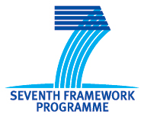

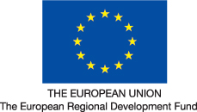
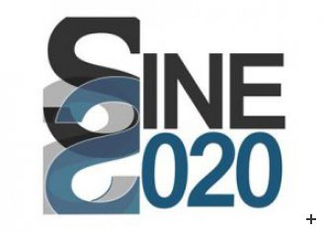
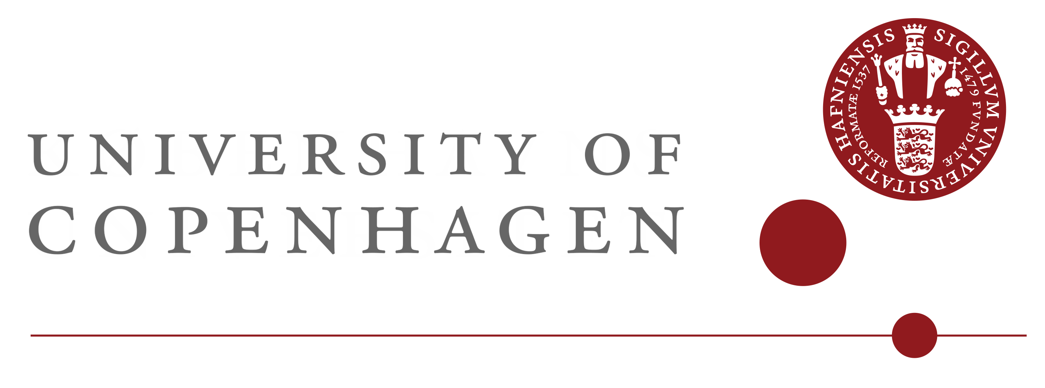
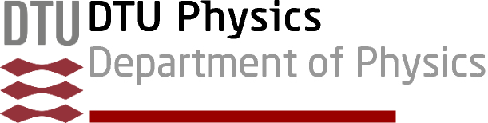
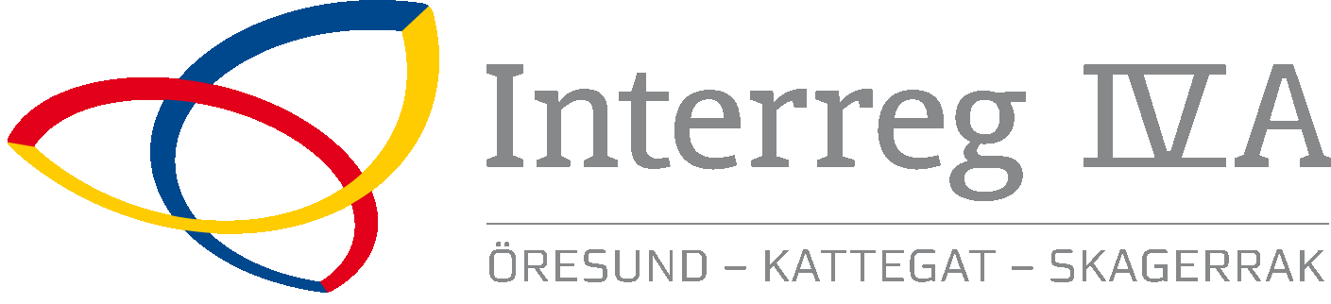

Footer on all pages contained:
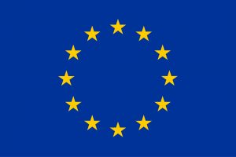 This project has received funding from the EU FP 7 grant No. 283883, Horizon 2020 grant agreement No. 654000 and Horizon 2020 grant agreement No. 823852. 